**VPN Gateway**



**Azure VPN Gateway** is a managed service that securely connects your on-premises network (or another virtual network) to your Azure Virtual Network (VNet) over an encrypted **IPsec/IKE VPN tunnel**.

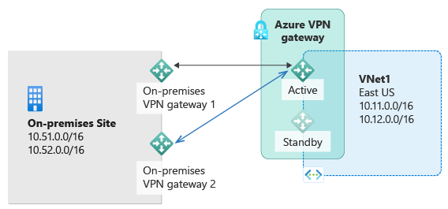

It is essentially a virtual network gateway appliance deployed in your VNet to enable secure hybrid connectivity.

**Features :**

1. **Site-to-Site VPN** — Connects your on-premises network to Azure VNet over IPsec/IKE VPN.
2. **Point-to-Site VPN** — Allows individual devices/users to connect securely to Azure VNet.
3. **VNet-to-VNet** — Securely connects two or more Azure VNets in different regions.
4. **High Availability** — Supports active-active configuration and SLA-backed uptime.
5. **Policy-based & Route-based VPNs** — Supports both VPN configurations depending on your needs.
6. **Cross-Premises & Cross-Cloud** — Can connect Azure to on-prem or even another cloud provider.